AutoEmail Update Tests
Tester: Tony Tasker
Date: 20th March 2017
Time: 12:00
PC/Server: TonyTasker-PC\SQL2014STD
Database: N/A
Works Summary: N/A
Works Order: N/A
Task: N/A
Notes: These tests were performed using Microsoft SQL Server Management Studio. Output to the Results and Messages Output Windows are used to determine the success of the tests.

The tests were performed using a SQL script that was specifically developed to test uf_GetEmailSendTime functionality (called Test_GetEmailSendTime functionality).

Purpose

- To test impact of changes to the Frequency setting in X CABS Configuration on the send date and time of an autoemail. Specifcally testing Time Type B4 with emails not being sent on weekends or bank holidays.

Requirement is that emails relating to all functions in a 24 hour window starting from the next day at 7:00 will be sent.

If the send day happens to be a weekend then emails will be sent on the previous Friday.

Pre-Test Setup
No | Task | Tester | Pass | Notes
1 | None

Post-Test Setup
No | Task | Tester | Pass | Notes
1 | None

Tests

Function to Start Next Day 21/03/2017 07:01
No | Test | Tester | Pass | Notes
1 | In SSMS open a new query window and open script Test_GetEmailSendTime | TT
2 | Set the variables as below:  DECLARE @CreateDate DATETIME = '03-20-2017 12:00:00'  DECLARE @StartDate DATETIME = '03-21-2017 07:01:00'  DECLARE @EndDate DATETIME = '03-21-2017 17:00:00'  DECLARE @Frequency VARCHAR(1000) = 'D:01;H:7;M:0;W:0;S:0;T:0700;L:B4' | TT |  | Testing an email from a function at the start of the send window
3 | Execute Script | TT |  | Output is detailed in Figure below

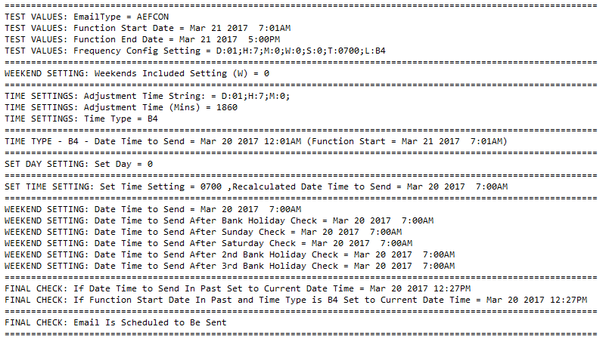
Figure 1 – Function Start Next Day 21/03/2017 7:01 – Email To Be Sent

Function to Start 22/03/2017 06:59
No | Test | Tester | Pass | Notes
1 | In SSMS open a new query window and open script Test_GetEmailSendTime | TT
2 | Set the variables as below:  DECLARE @CreateDate DATETIME = '03-20-2017 12:00:00'  DECLARE @StartDate DATETIME = '03-22-2017 06:59:00'  DECLARE @EndDate DATETIME = '03-22-2017 17:00:00'  DECLARE @Frequency VARCHAR(1000) = 'D:01;H:7;M:0;W:0;S:0;T:0700;L:B4' | TT |  | Testing an email from a function at the end of the send window
3 | Execute Script | TT |  | Output is detailed in Figure below

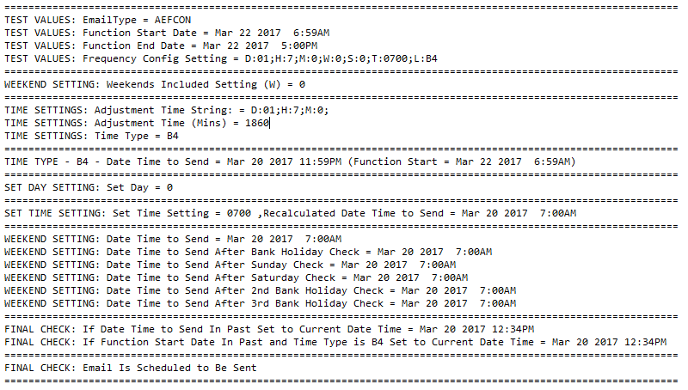
Figure 2 – Function Start 22/03/2017 06:59 – Email To Be Sent

Function to Start 22/03/2017 07:01
No | Test | Tester | Pass | Notes
1 | In SSMS open a new query window and open script Test_GetEmailSendTime | TT
2 | Set the variables as below:  DECLARE @CreateDate DATETIME = '03-20-2017 12:00:00'  DECLARE @StartDate DATETIME = '03-22-2017 07:01:00'  DECLARE @EndDate DATETIME = '03-22-2017 17:00:00'  DECLARE @Frequency VARCHAR(1000) = 'D:01;H:7;M:0;W:0;S:0;T:0700;L:B4' | TT |  | Testing an email from a function just outside of the send window
3 | Execute Script | TT |  | Output is detailed in Figure below

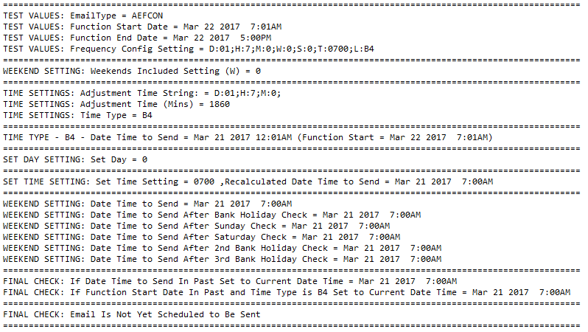
Figure 3 – Function Start 22/03/2017 7:01 – Email Not To Be Sent

Function to Start 28/03/2017 06:59 (Tuesday)
No | Test | Tester | Pass | Notes
1 | In SSMS open a new query window and open script Test_GetEmailSendTime | TT
2 | Set the variables as below:  DECLARE @CreateDate DATETIME = '03-20-2017 12:00:00'  DECLARE @StartDate DATETIME = '03-28-2017 06:59:00'  DECLARE @EndDate DATETIME = '03-28-2017 17:00:00'  DECLARE @Frequency VARCHAR(1000) = 'D:01;H:7;M:0;W:0;S:0;T:0700;L:B4' | TT |  | Testing an email from a function which would naturally be sent on a Sunday but is adjusted because weekends are not included.
3 | Execute Script | TT |  | Output is detailed in Figure below

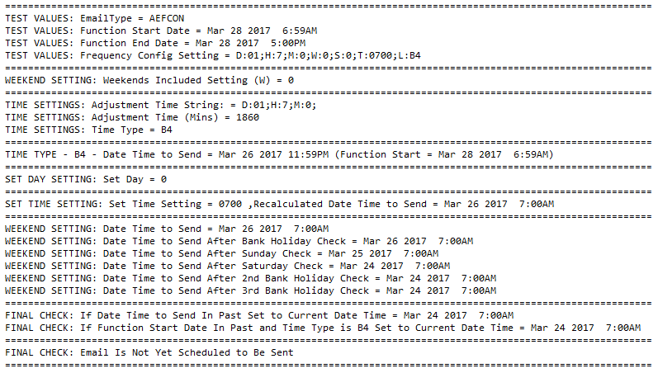
Figure 4 – Function Start 28/03/2017 06:59 – Email Not To Be Sent But Will Be Sent On Friday

Function to Start 28/03/2017 06:59 (Tuesday) – Weekends Included
No | Test | Tester | Pass | Notes
1 | In SSMS open a new query window and open script Test_GetEmailSendTime | TT
2 | Set the variables as below:  DECLARE @CreateDate DATETIME = '03-20-2017 12:00:00'  DECLARE @StartDate DATETIME = '03-28-2017 06:59:00'  DECLARE @EndDate DATETIME = '03-28-2017 17:00:00'  DECLARE @Frequency VARCHAR(1000) = 'D:01;H:7;M:0;W:1;S:0;T:0700;L:B4' | TT |  | Testing an email from a function which would be sent on a Sunday and is not adjusted because weekends are included.
3 | Execute Script | TT |  | Output is detailed in Figure below

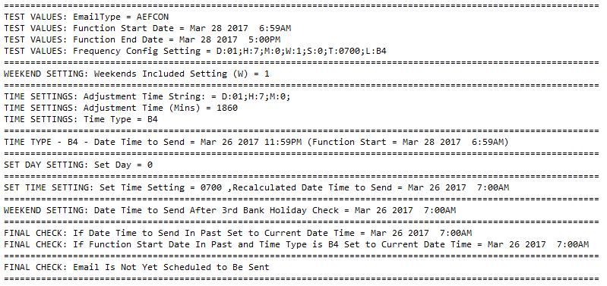
Figure 5 – Function Start 28/03/2017 06:59 – Email Not To Be Sent But Will Be Sent On Sunday

